[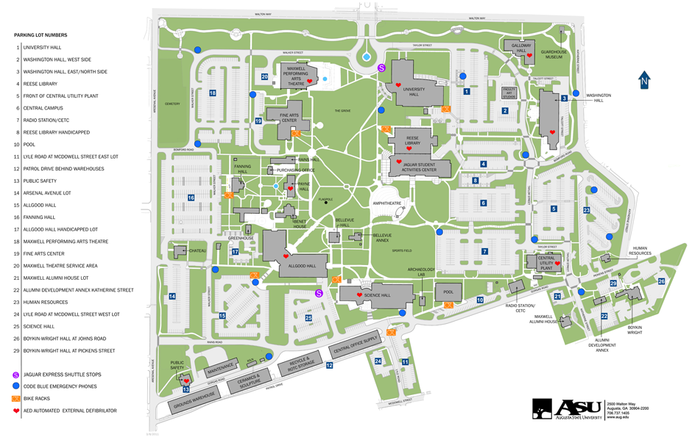](http://www.aug.edu/public_relations/asumap/images/campusmapfull.png)

University Hall – SEDII Event Site

Parking Lot





Temporary Parking Pass for: **SEDII STARTALK Teacher Program**

Expires: **07/22/2013 – 07/24/2013**

For Student and Visitor space

Please display on your dash board for parking on campus.

GRU Augusta - Summerville Campus

2500 Walton Way, Augusta, GA 30904 /Parking Services 706-729-2090

706.737.1661 / ltcoleman@gru.edu

Parking Services 706-729-2090 Approved by Parking Services 01/18/2013